IONIC EQUILIBRIUM
Theory of Acids and bases
Arrhenius Theory
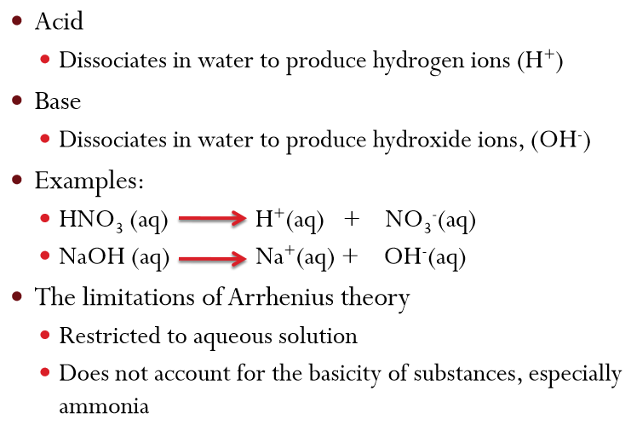
BrØnsted – Lowry Theory
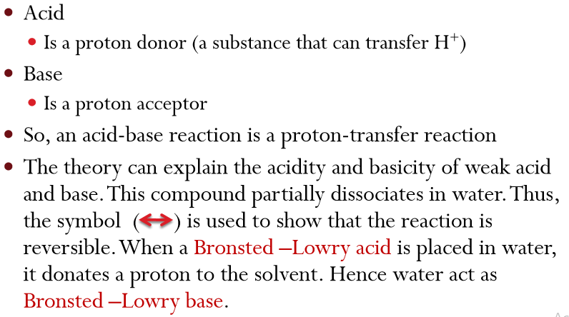
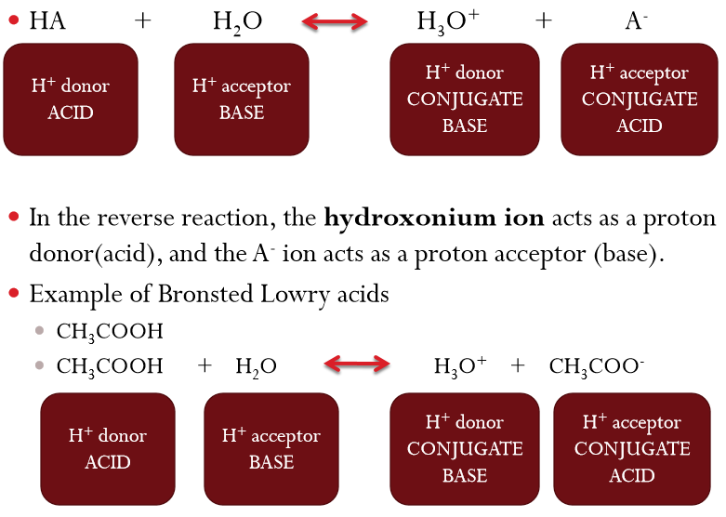
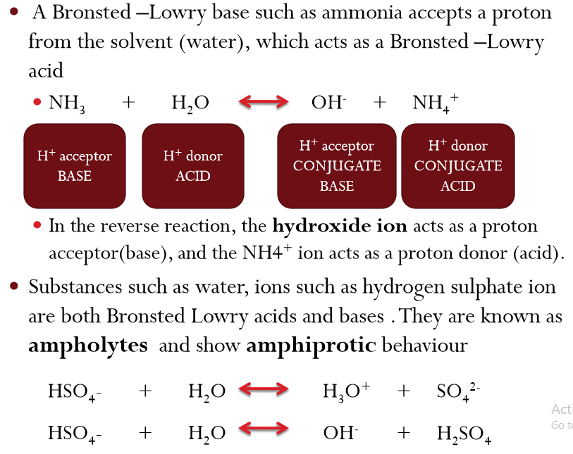

Exercises
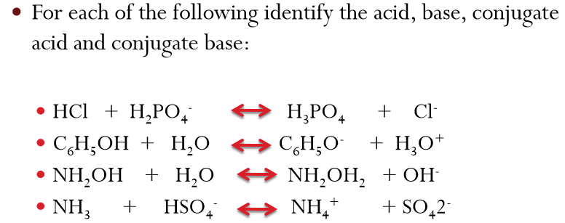
Lewis Theory 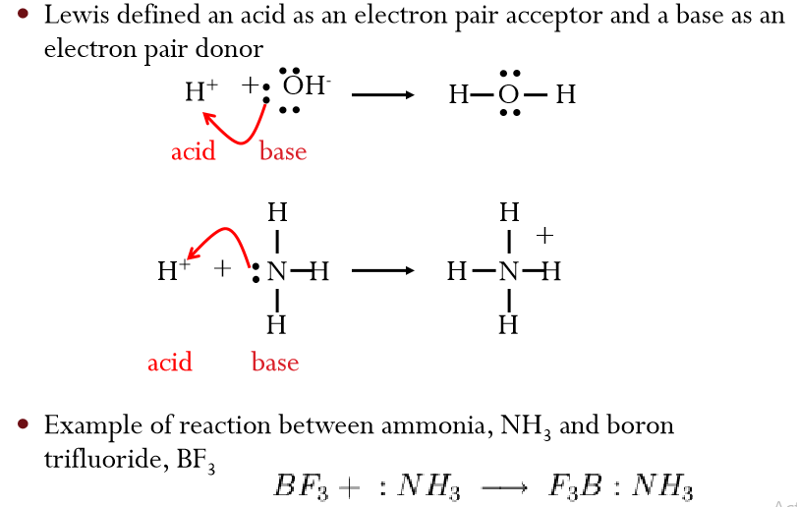
Relative Strength of Bronsted –Lowry Acids and Bases
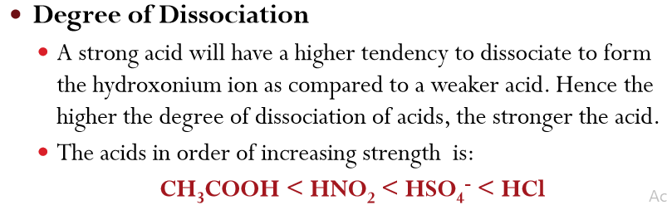
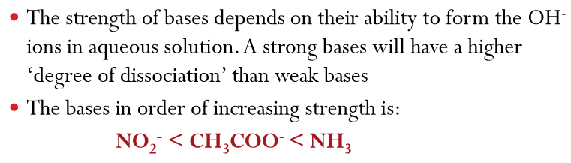Acid/Base Dissociation Constant (Ka and Kb) 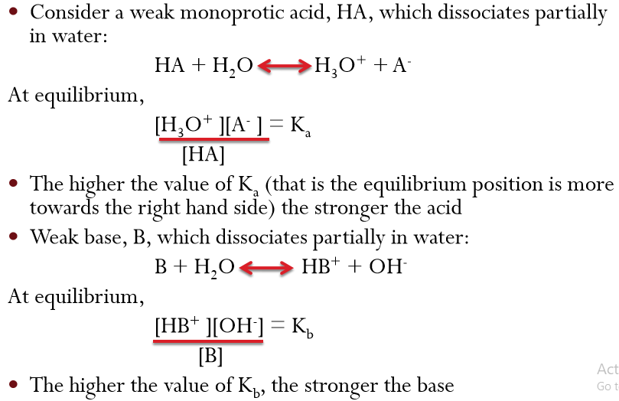
pKa and pKb
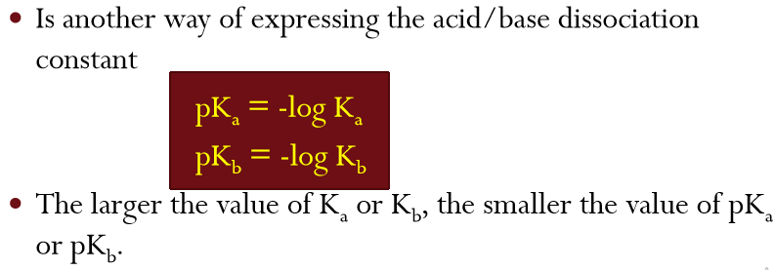
Ostwald Dilution Law and Dissociation Constant
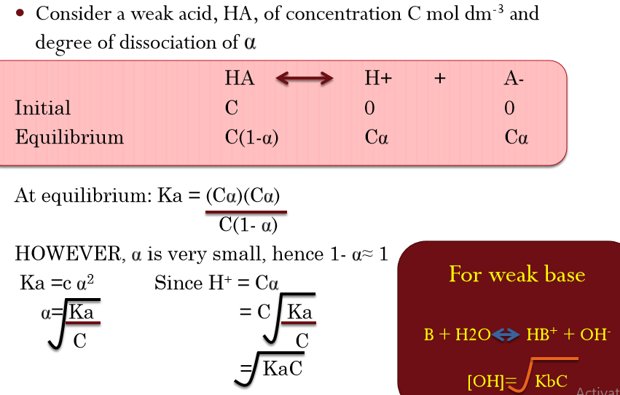
Ionic Product of Water
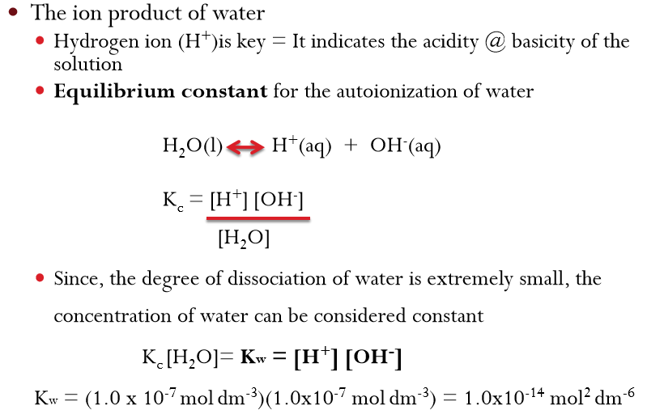

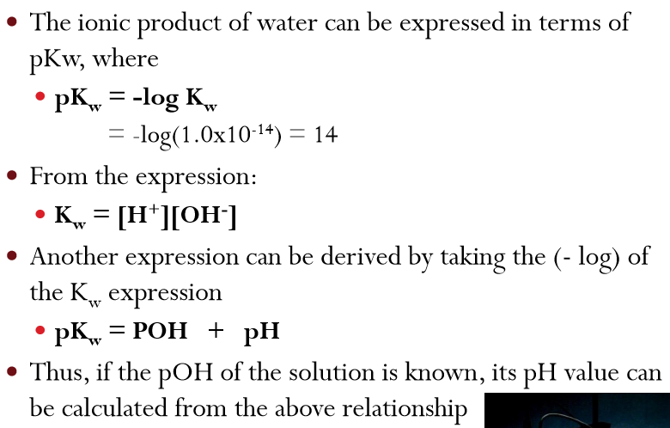
Measurement of acidity and basicity
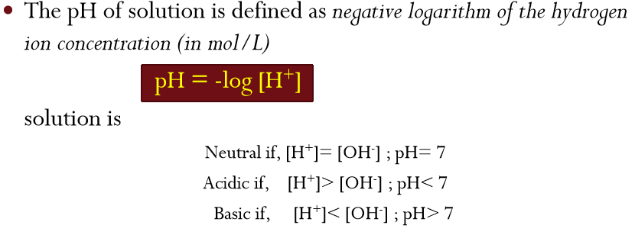
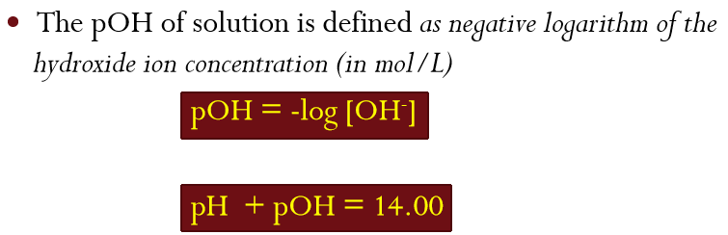
Relationship between pKa, pKb and pKw
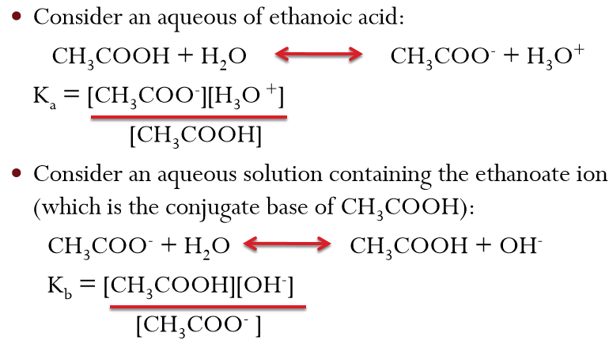
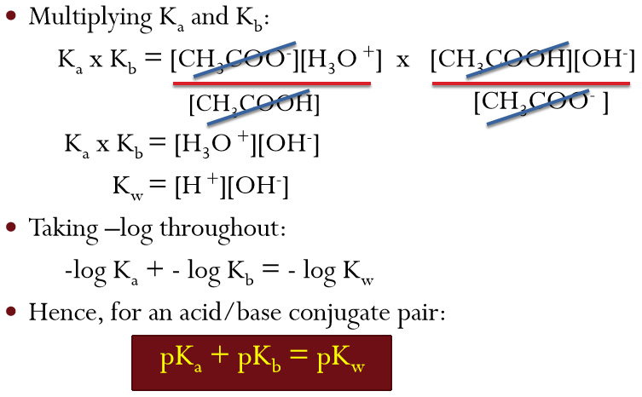
Example
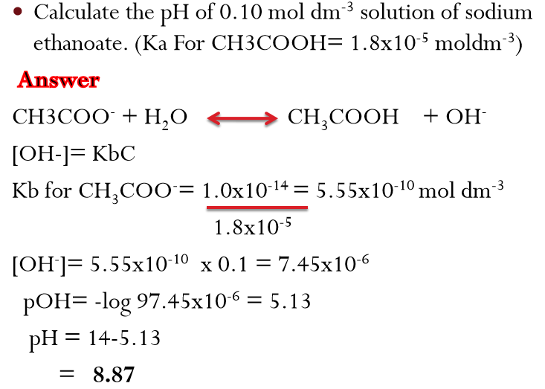
Acid-Base Titration
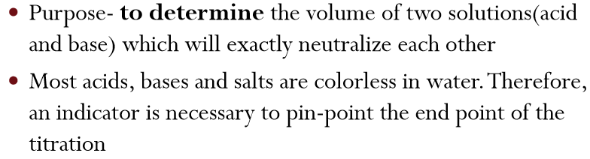
Acid-Base Indicators
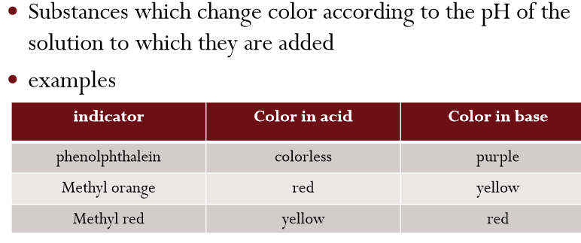
Equivalent point and End point of Acid Base Titration
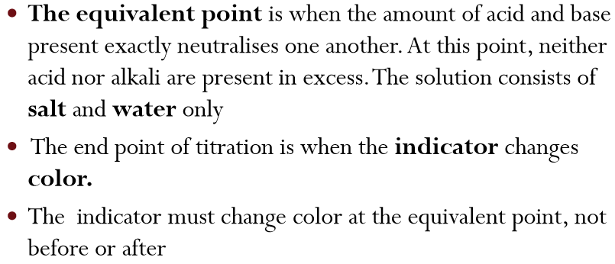
Suitable Indicator
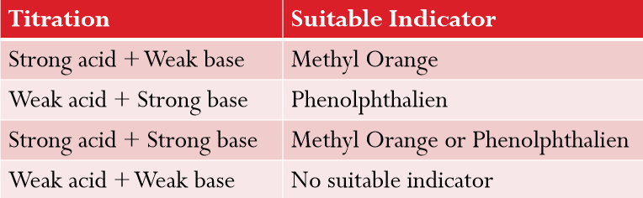
Acid-Base Properties of Salts
Neutral Solutions:
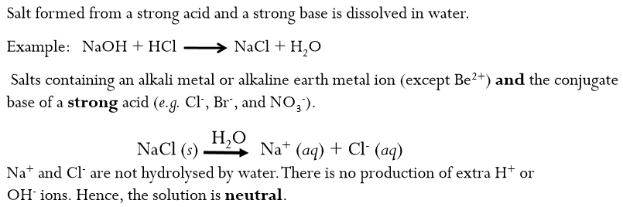
Basic Solutions:
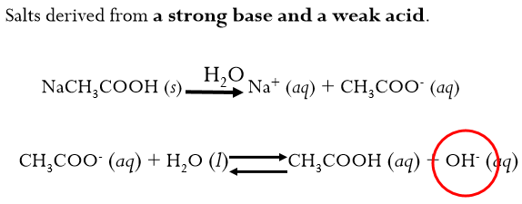
Acid-Base Properties of Salts
Acidic solution.
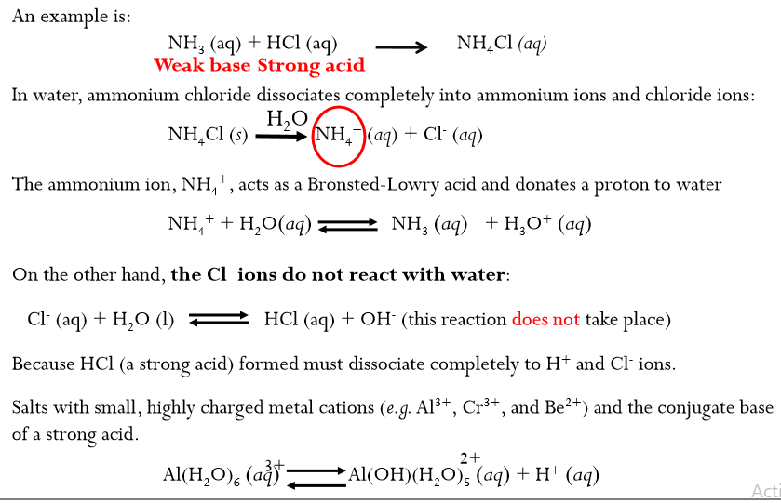
Acid Hydrolysis of Al3+
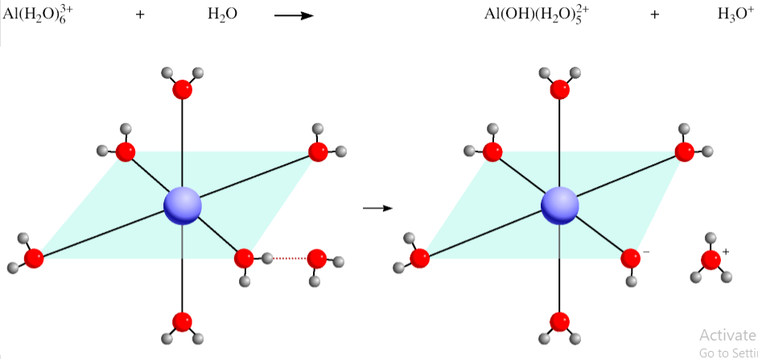
Acid-Base Properties of Salts
Solutions in which both the cation and the anion hydrolyze:
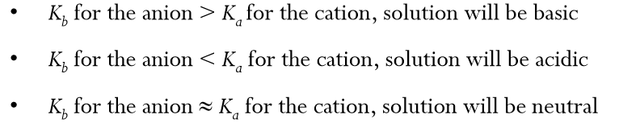
Acid-Base Properties of Salts
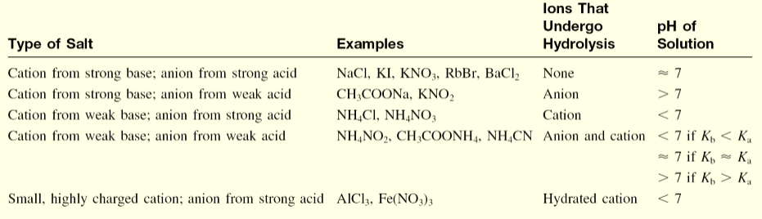
Hydrolysis
Remembering the following equations must hold simultaneously
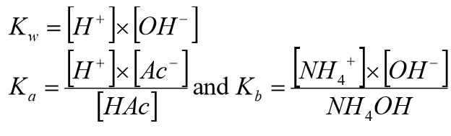

Also, it can be shown that
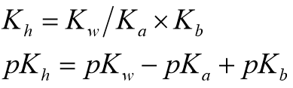
Buffer System
Is a solution of a weak acid and its salt to form acidic buffer solution or weak base and its salt to form basic buffer solution. A buffer solution has the ability to resist changes in pH upon the addition of small amounts of either acid or base.
Acidic Buffer Solution
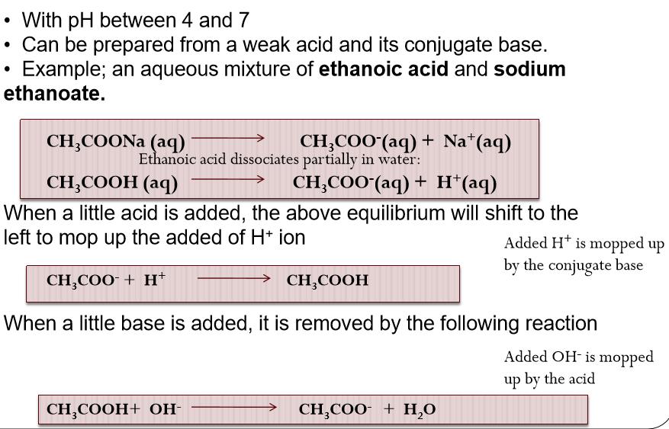

Basic Buffer Solution
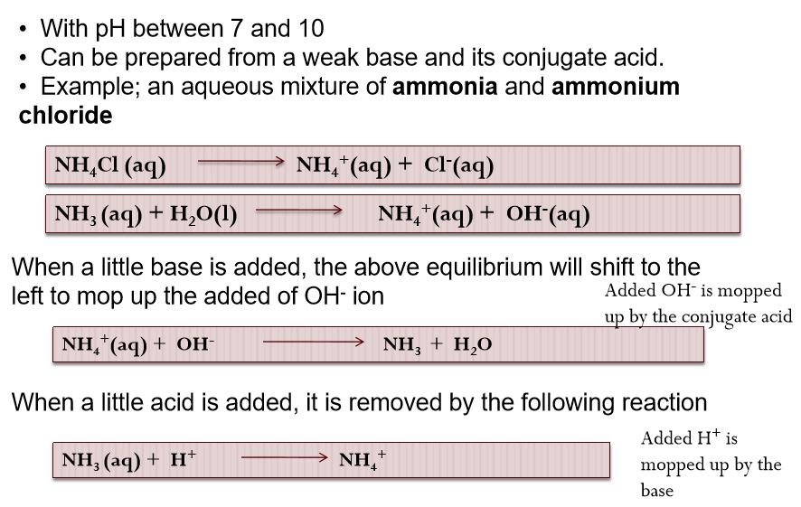
Exercise
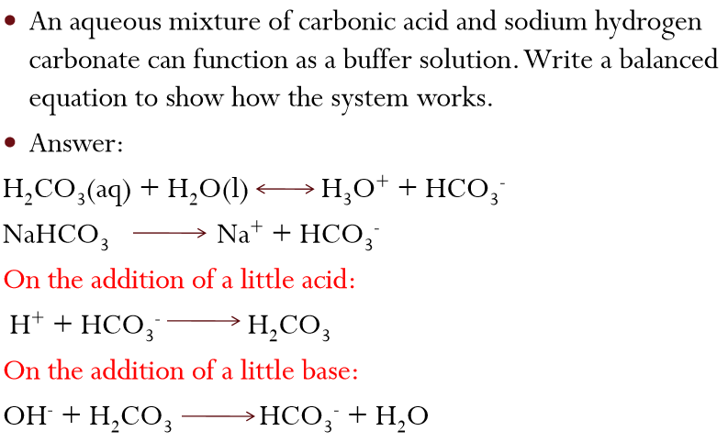

pH of Buffer Solutions
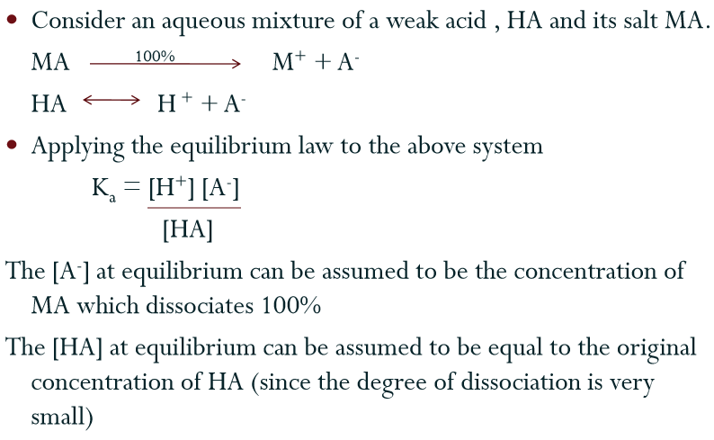
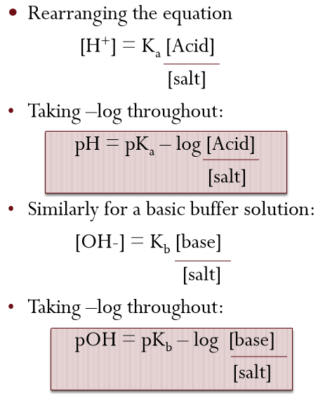
Theory and application of buffer system Maintaining the pH of blood
